SOAP UI Tutorial:

SOAP UI Download link:

SOAP UI Tool: <http://www.soapui.org/downloads/soapui/open-source.html>

Direct link

http://cdn01.downloads.smartbear.com/soapui/5.2.0/SoapUI-5.2.0-win32-standalone-bin.zip#_ga=1.207420501.757169327.1443285225

Step 1: Create a SOAP service and publish.

Ex:

**package** com.app;

**import** javax.jws.WebMethod;

**import** javax.jws.WebService;

@WebService

**public** **class** Calculations {

@WebMethod

**public** String sayHello(String name){

**return** "Welcome to Sample Prgm:"+name;

}

}

Publisher:

**package** com.app;

**import** javax.xml.ws.Endpoint;

**public** **class** Publisher {

**public** **static** **void** main(String[] args) {

String uri="http://localhost:9900/ws/abcd";

Calculations calcObj=**new** Calculations();

Endpoint.*publish*(uri, calcObj);

System.*out*.println("done");

}

}

Step 2) Open SOAP UI: File-> New SOAP Project

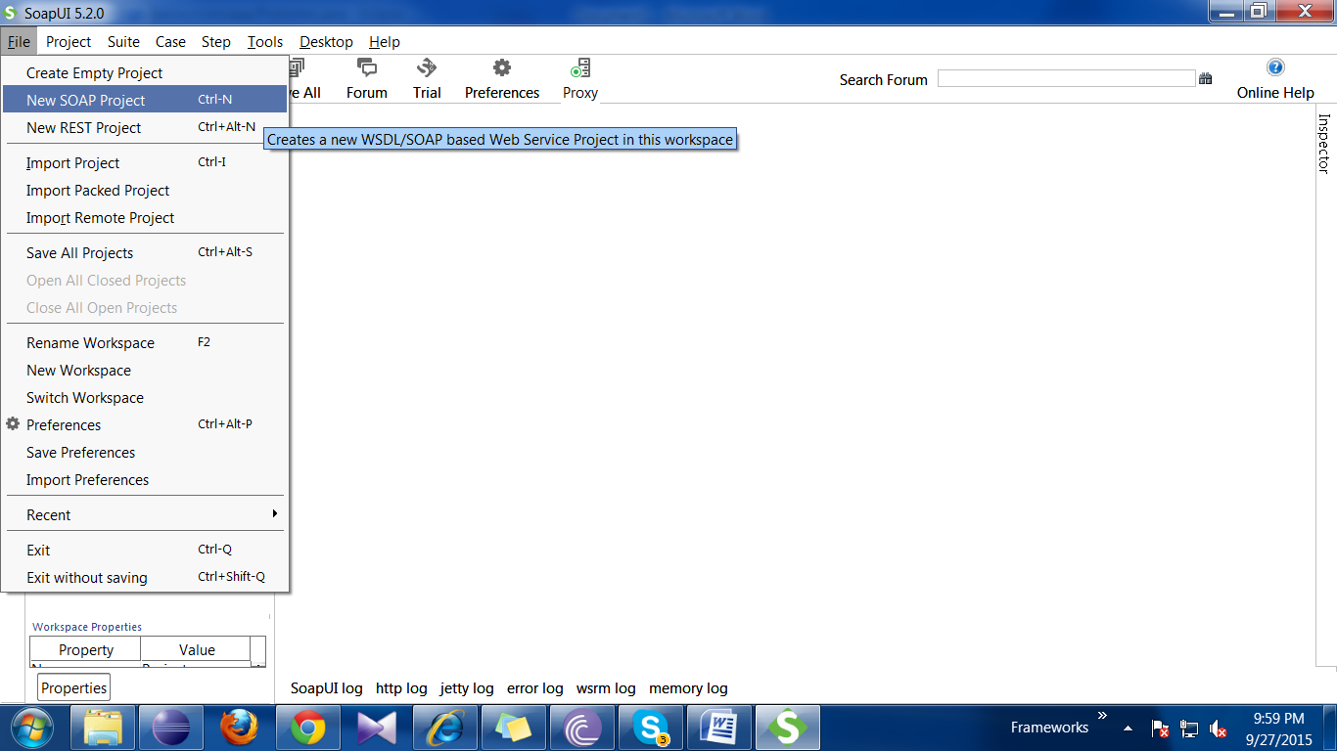

Step 3) Enter Project name and WSDL Location :

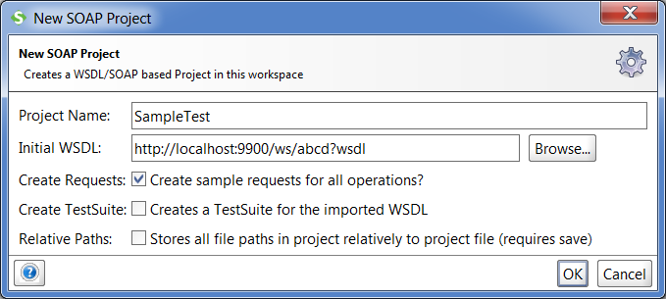

Step 4) Click on Ok Button. And Expand the Project to Make Request. as Shown Below.

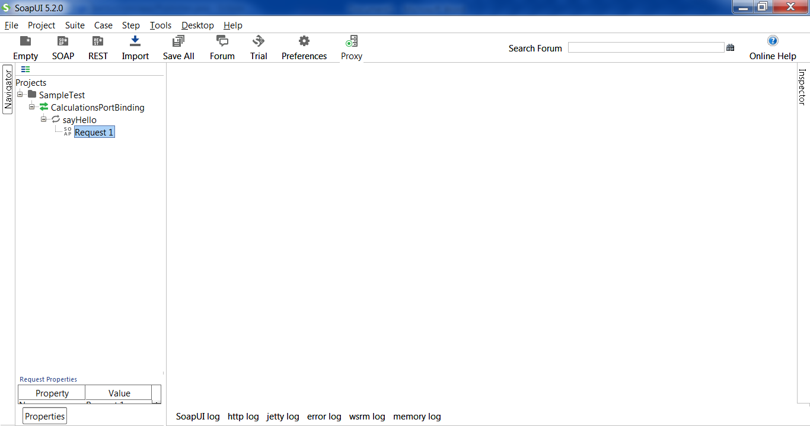

Step 5) On double Click on Request1 Option. One new POPUP Window will appear to make request. Fill Data At ? symbol and Click on submit(Play Symbol) Request. Once Request Submitted, Response Will be show at right side window

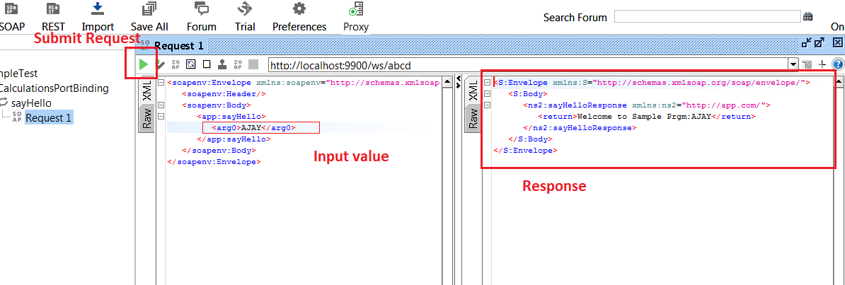

--------------

Observe Response Headers :

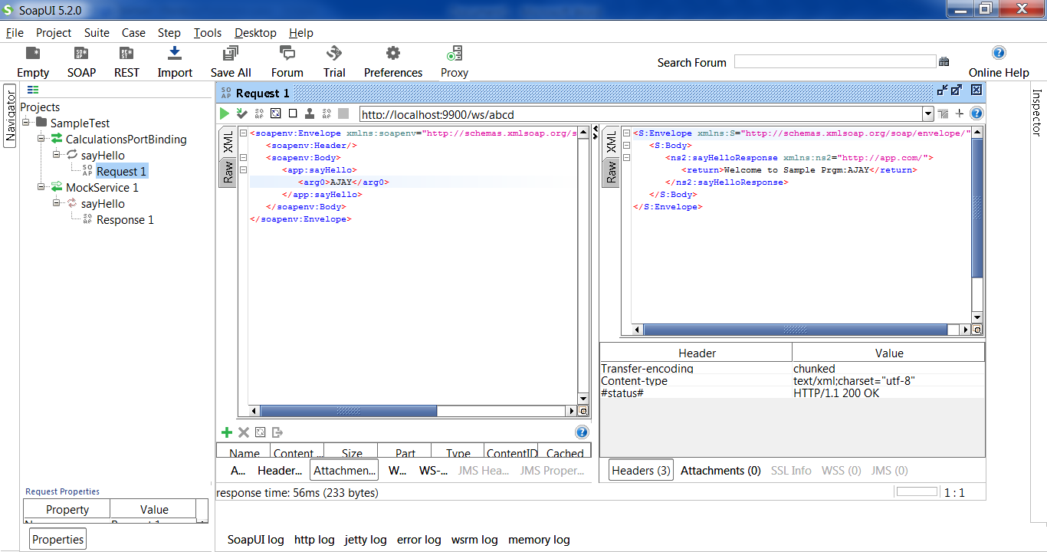

Step 6) Double Click on Port Binding (<=> symbol) to see all details along with WSDL File

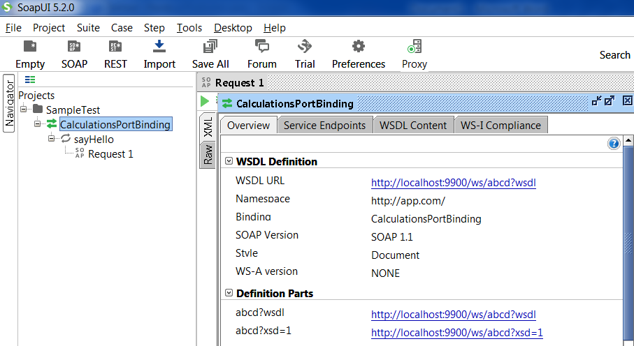

Try To work on below WSDL links:

http://www.webservicex.net/CurrencyConvertor.asmx?WSDL

http://www.webservicex.net/globalweather.asmx?WSDL